AI Parenting Survey (Text)

Adam Jauregui

8/12/2019

Started with n=358 survey observations in downloaded Qualtrics file after Turkprime ended recruitment on xx/xx/xx

1. Subset out non-consenters (n= 338)
2. Delete test observations (“test” or “turkprime” entered in any fields) (n= 335)
3. Delete observations if youngest child age >5 (n=29); n=306 remaining
4. Delete observations if duration < 140sec (n=23); n=283
   1. Mean duration = 508, s.d. duration = 457 (both not including duration=50k sec); median = 379
5. Delete observation where gender is not “male” or “female”; n = 282

|  |  |  |  |  |
| --- | --- | --- | --- | --- |
| Variable | Stats / Values | Freqs (% of Valid) | Graph | Missing |
| Duration(Seconds) | Mean (sd) : 684 (3000.7) min < med < max: 145 < 379 < 50402 IQR (CV) : 337 (4.4) | 229 distinct values |  | 0 (0%) |
| UserLanguage | 1. EN 2. ES 3. ES-ES 4. JA | 250 (88.3%) 23 (8.1%) 9 (3.2%) 1 (0.4%) |  | 0 (0%) |
| Q1Consent Form | 1. 1 | 283 (100.0%) |  | 0 (0%) |

Q3: How important is it for a parent to teach their child to…

|  |  |  |  |  |
| --- | --- | --- | --- | --- |
| 1. Language skills (e.g., the names of objects, how to put together sentences, or to use proper grammar) | 1. Not at all Important 2. Slightly important 3. Important 4. Very important 5. Extremely Important | 3 (1.1%) 7 (2.5%) 26 (9.2%) 66 (23.3%) 181 (64.0%) |  | 0 (0%) |
| 2. Math skills (e.g., the names of numbers, how to count, or how to add/subtract) | 1. Not at all Important 2. Slightly important 3. Important 4. Very important 5. Extremely Important | 3 (1.1%) 9 (3.2%) 27 (9.5%) 111 (39.2%) 133 (47.0%) |  | 0 (0%) |
| 3. Motor skills (e.g., how to crawl, run or walk, how to feed themselves, or fine motor skills like using a pencil) | 1. Not at all Important 2. Slightly important 3. Important 4. Very important 5. Extremely Important | 6 (2.1%) 6 (2.1%) 33 (11.7%) 60 (21.2%) 178 (62.9%) |  | 0 (0%) |
| 4. Emotional intelligence (e.g., how to seek help when they are upset, how to express their emotions, or how to calm them self down) | 1. Not at all Important 2. Slightly important 3. Important 4. Very important 5. Extremely Important | 2 (0.7%) 8 (2.8%) 23 (8.2%) 65 (23.1%) 184 (65.2%) |  | 1 (0.35%) |
| 5. Independence (e.g., developing self-confidence, the ability to play on their own without an adult, or how to figure out how things work by themselves) | 1. Not at all Important 2. Slightly important 3. Important 4. Very important 5. Extremely Important | 3 (1.1%) 6 (2.1%) 37 (13.1%) 80 (28.4%) 156 (55.3%) |  | 1 (0.35%) |
| 6. Social skills (e.g., the importance of following the rules, how to share and take turns, or respecting other people’s boundaries) | 1. Not at all Important 2. Slightly important 3. Important 4. Very important 5. Extremely Important | 4 (1.4%) 8 (2.8%) 26 (9.2%) 74 (26.2%) 170 (60.3%) |  | 1 (0.35%) |

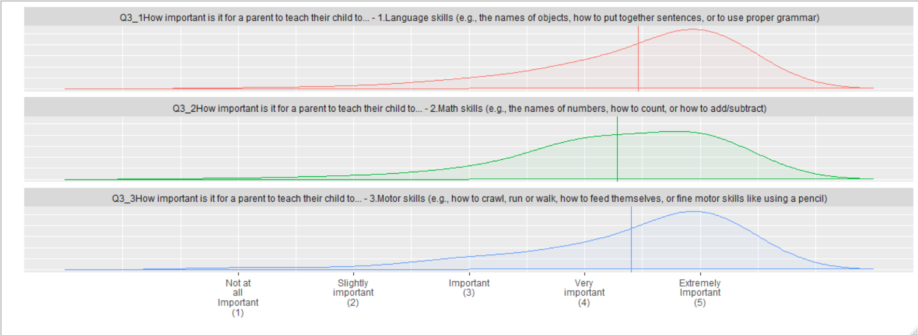

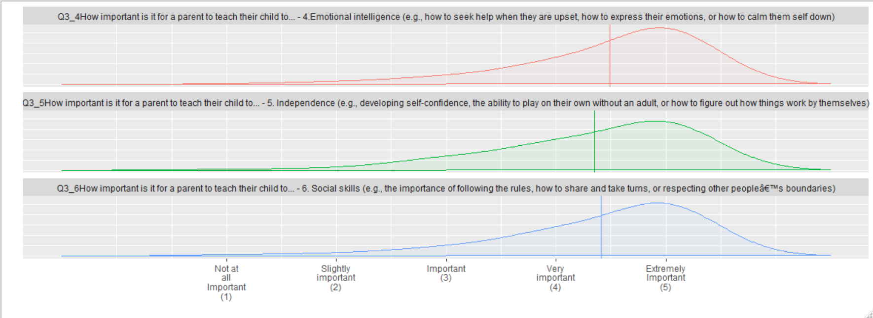

Q5. In a typical day, for about how many HOURS do you use each of the following:

|  |  |  |  |  |
| --- | --- | --- | --- | --- |
| 7. A television (TV) | 1. 0 hours 2. <1 hour 3. 1 hour 4. 2 hours 5. 3 hours 6. 4+ hours | 11 (3.9%) 28 (9.9%) 34 (12.1%) 69 (24.5%) 65 (23.1%) 75 (26.6%) |  | 1 (0.35%) |
| 8. A desktop or laptop computer | 1. 0 hours 2. <1 hour 3. 1 hour 4. 2 hours 5. 3 hours 6. 4+ hours | 46 (16.2%) 47 (16.6%) 35 (12.4%) 39 (13.8%) 35 (12.4%) 81 (28.6%) |  | 0 (0%) |
| 9. A mobile phone without internet connectivity | 1. 0 hours 2. <1 hour 3. 1 hour 4. 2 hours 5. 3 hours 6. 4+ hours | 149 (52.6%) 40 (14.1%) 20 (7.1%) 23 (8.1%) 25 (8.8%) 26 (9.2%) |  | 0 (0%) |
| 10. A mobile phone with internet connectivity (smartphone) | 1. 0 hours 2. <1 hour 3. 1 hour 4. 2 hours 5. 3 hours 6. 4+ hours | 13 (4.6%) 16 (5.6%) 40 (14.1%) 38 (13.4%) 52 (18.4%) 124 (43.8%) |  | 0 (0%) |
| 11. A tablet (e.g., iPad, Kindle Fire, Galaxy Touch) | 1. 0 hours 2. <1 hour 3. 1 hour 4. 2 hours 5. 3 hours 6. 4+ hours | 108 (38.2%) 45 (15.9%) 43 (15.2%) 35 (12.4%) 21 (7.4%) 31 (10.9%) |  | 0 (0%) |
| 12. Other handheld electronic devices (e.g., iPod touch, Apple Watch, Kindle) | 1. 0 hours 2. <1 hour 3. 1 hour 4. 2 hours 5. 3 hours 6. 4+ hours | 161 (56.9%) 37 (13.1%) 24 (8.5%) 24 (8.5%) 14 (5.0%) 23 (8.1%) |  | 0 (0%) |
| 13. A video game console | 1. 0 hours 2. <1 hour 3. 1 hour 4. 2 hours 5. 3 hours 6. 4+ hours | 116 (41.0%) 46 (16.2%) 42 (14.8%) 37 (13.1%) 24 (8.5%) 18 (6.4%) |  | 0 (0%) |

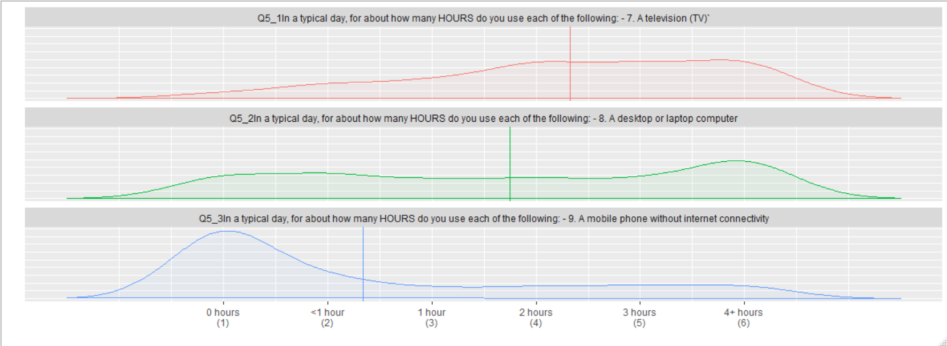

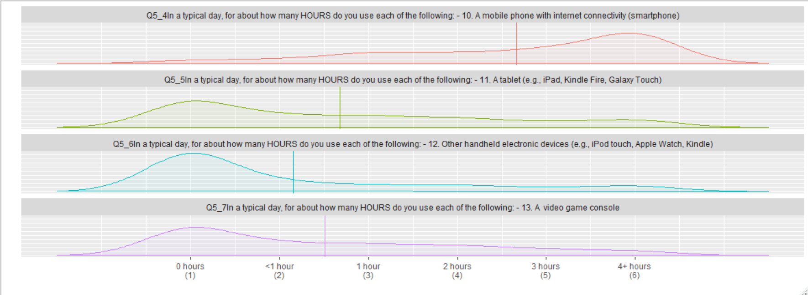

Q7. In a typical day, for about how many HOURS do you use mobile electronic devices to do each of the following:

|  |  |  |  |  |
| --- | --- | --- | --- | --- |
| 14. Shopping | 1. 0 hours 2. <1 hour 3. 1 hour 4. 2 hours 5. 3 hours 6. 4+ hours | 63 (22.3%) 107 (37.8%) 54 (19.1%) 26 (9.2%) 20 (7.1%) 13 (4.6%) |  | 0 (0%) |
| 15. Playing games | 1. 0 hours 2. <1 hour 3. 1 hour 4. 2 hours 5. 3 hours 6. 4+ hours | 49 (17.4%) 64 (22.8%) 53 (18.9%) 55 (19.6%) 26 (9.2%) 34 (12.1%) |  | 2 (0.71%) |
| 16. Watching videos | 1. 0 hours 2. <1 hour 3. 1 hour 4. 2 hours 5. 3 hours 6. 4+ hours | 30 (10.6%) 77 (27.3%) 61 (21.6%) 45 (16.0%) 33 (11.7%) 36 (12.8%) |  | 1 (0.35%) |
| 17. Seeking general information | 1. 0 hours 2. <1 hour 3. 1 hour 4. 2 hours 5. 3 hours 6. 4+ hours | 12 (4.2%) 83 (29.3%) 74 (26.2%) 56 (19.8%) 27 (9.5%) 31 (10.9%) |  | 0 (0%) |
| 18. Seek information on parenting or caregiving | 1. 0 hours 2. <1 hour 3. 1 hour 4. 2 hours 5. 3 hours 6. 4+ hours | 59 (20.8%) 101 (35.7%) 44 (15.6%) 34 (12.0%) 28 (9.9%) 17 (6.0%) |  | 0 (0%) |
| 19. Seek information on your child’s health | 1. 0 hours 2. <1 hour 3. 1 hour 4. 2 hours 5. 3 hours 6. 4+ hours | 54 (19.1%) 106 (37.5%) 58 (20.5%) 27 (9.5%) 19 (6.7%) 19 (6.7%) |  | 0 (0%) |
| 20. Post information on parenting or caregiving – to help others | 1. 0 hours 2. <1 hour 3. 1 hour 4. 2 hours 5. 3 hours 6. 4+ hours | 112 (39.6%) 79 (27.9%) 41 (14.5%) 24 (8.5%) 13 (4.6%) 14 (5.0%) |  | 0 (0%) |
| 21. Post information on child health – to help others | 1. 0 hours 2. <1 hour 3. 1 hour 4. 2 hours 5. 3 hours 6. 4+ hours | 121 (42.8%) 74 (26.2%) 37 (13.1%) 22 (7.8%) 11 (3.9%) 18 (6.4%) |  | 0 (0%) |

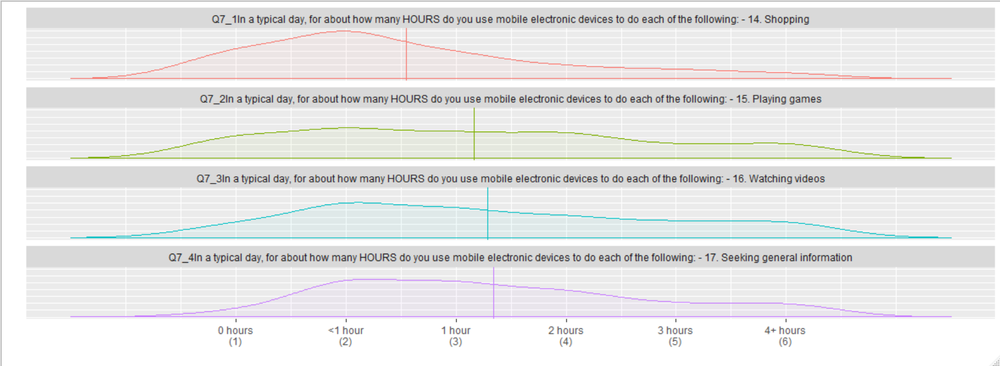

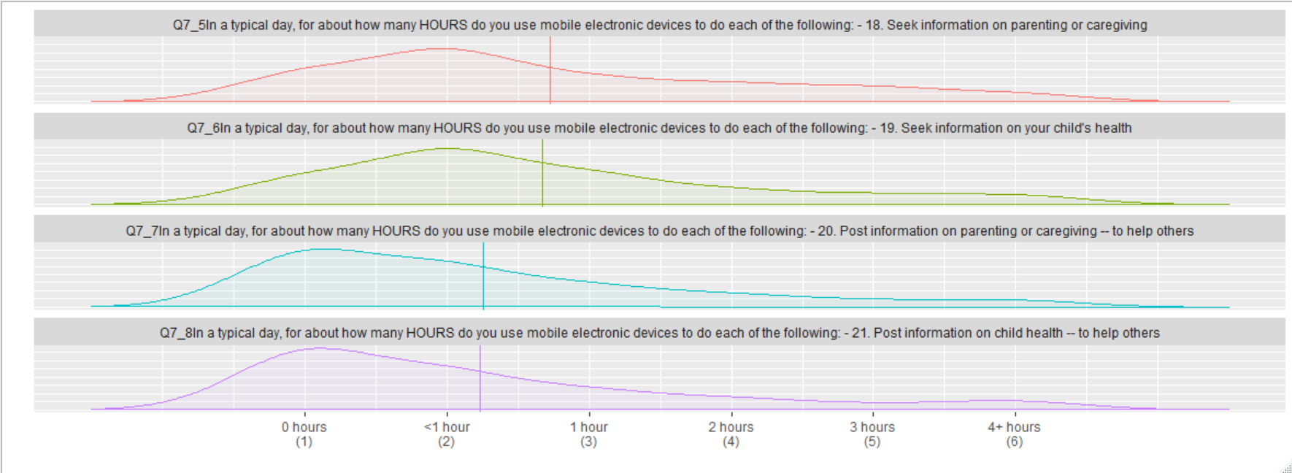

Q8. In a typical day, how many TIMES does each of the following devices interrupt a conversation or activity between you and your child?

|  |  |  |  |  |
| --- | --- | --- | --- | --- |
| 22. A television (TV) | 1. 0 times 2. 1 time 3. 2 times 4. 3 times 5. 4+ times | 107 (37.8%) 64 (22.6%) 53 (18.7%) 36 (12.7%) 23 (8.1%) |  | 0 (0%) |
| 23. A desktop or laptop computer | 1. 0 times 2. 1 time 3. 2 times 4. 3 times 5. 4+ times | 144 (50.9%) 60 (21.2%) 45 (15.9%) 16 (5.6%) 18 (6.4%) |  | 0 (0%) |
| 24. A mobile phone without internet connectivity | 1. 0 times 2. 1 time 3. 2 times 4. 3 times 5. 4+ times | 181 (64.0%) 34 (12.0%) 37 (13.1%) 21 (7.4%) 10 (3.5%) |  | 0 (0%) |
| 25. A mobile phone with internet connectivity (smartphone) | 1. 0 times 2. 1 time 3. 2 times 4. 3 times 5. 4+ times | 69 (24.4%) 62 (21.9%) 70 (24.7%) 50 (17.7%) 32 (11.3%) |  | 0 (0%) |
| 26. A tablet (e.g., iPad, Kindle Fire, Galaxy touch) | 1. 0 times 2. 1 time 3. 2 times 4. 3 times 5. 4+ times | 163 (57.6%) 49 (17.3%) 38 (13.4%) 22 (7.8%) 11 (3.9%) |  | 0 (0%) |
| 27. Other handheld device (e.g., iPod touch, Apple Watch, Kindle) | 1. 0 times 2. 1 time 3. 2 times 4. 3 times 5. 4+ times | 196 (69.3%) 38 (13.4%) 27 (9.5%) 14 (5.0%) 8 (2.8%) |  | 0 (0%) |
| 28. A video game console | 1. 0 times 2. 1 time 3. 2 times 4. 3 times 5. 4+ times | 161 (56.9%) 54 (19.1%) 39 (13.8%) 16 (5.6%) 13 (4.6%) |  | 0 (0%) |

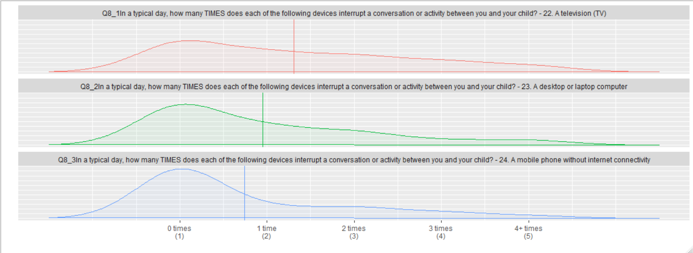

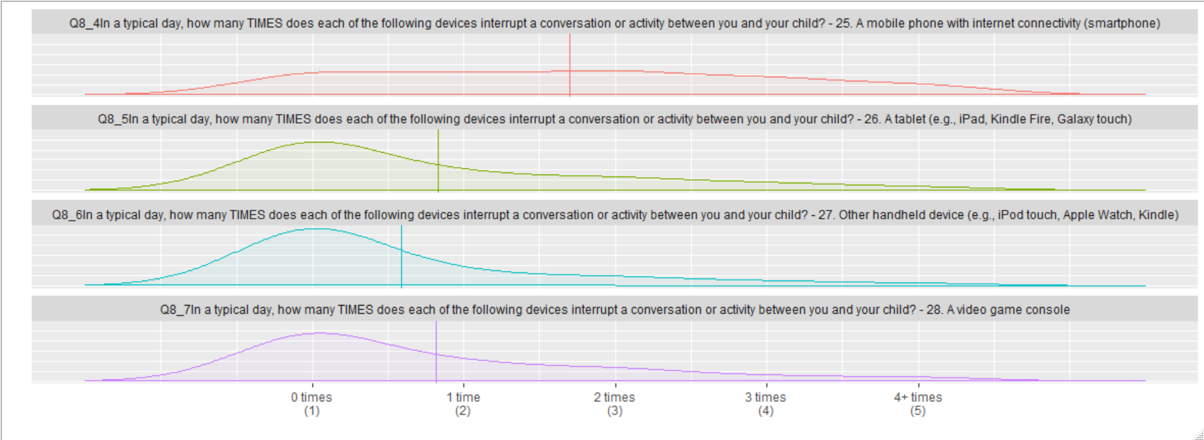

Q8. Please rate your agreement with each statement, using the following scale:

|  |  |  |  |  |
| --- | --- | --- | --- | --- |
| 29. When my mobile electronic device alerts me to indicate new messages, I cannot resist checking them. | 1. Strongly Disagree 2. Disagree 3. Slightly Disagree 4. Slightly Agree 5. Agree 6. Strongly Agree | 30 (10.6%) 35 (12.4%) 41 (14.5%) 72 (25.4%) 65 (23.0%) 40 (14.1%) |  | 0 (0%) |
| 30. I often think about calls or messages I might receive on my mobile phone. | 1. Strongly Disagree 2. Disagree 3. Slightly Disagree 4. Slightly Agree 5. Agree 6. Strongly Agree | 48 (17.0%) 55 (19.4%) 45 (15.9%) 55 (19.4%) 55 (19.4%) 25 (8.8%) |  | 0 (0%) |
| 31. I feel like I use my mobile phone too much. | 1. Strongly Disagree 2. Disagree 3. Slightly Disagree 4. Slightly Agree 5. Agree 6. Strongly Agree | 29 (10.2%) 23 (8.1%) 38 (13.4%) 63 (22.3%) 65 (23.0%) 65 (23.0%) |  | 0 (0%) |
| 32. Mobile electronic devices make parenting easier. | 1. Strongly Disagree 2. Disagree 3. Slightly Disagree 4. Slightly Agree 5. Agree 6. Strongly Agree | 26 (9.2%) 39 (13.8%) 60 (21.2%) 81 (28.6%) 56 (19.8%) 21 (7.4%) |  | 0 (0%) |
| 33. I am worried about the impact of my mobile electronic device use on my child. | 1. Strongly Disagree 2. Disagree 3. Slightly Disagree 4. Slightly Agree 5. Agree 6. Strongly Agree | 23 (8.2%) 30 (10.7%) 41 (14.6%) 65 (23.1%) 73 (26.0%) 49 (17.4%) |  | 2 (0.71%) |
| 34. I would like help in limiting my mobile electronic device use around my child. | 1. Strongly Disagree 2. Disagree 3. Slightly Disagree 4. Slightly Agree 5. Agree 6. Strongly Agree | 27 (9.6%) 33 (11.7%) 35 (12.4%) 56 (19.9%) 84 (29.8%) 47 (16.7%) |  | 1 (0.35%) |
| 35. Mobile electronic devices make parenting harder. | 1. Strongly Disagree 2. Disagree 3. Slightly Disagree 4. Slightly Agree 5. Agree 6. Strongly Agree | 30 (10.7%) 50 (17.8%) 64 (22.8%) 68 (24.2%) 51 (18.1%) 18 (6.4%) |  | 2 (0.71%) |
| 36. I have tried to limit my mobile electronic device use around my child. | 1. Strongly Disagree 2. Disagree 3. Slightly Disagree 4. Slightly Agree 5. Agree 6. Strongly Agree | 13 (4.6%) 15 (5.3%) 28 (10.0%) 85 (30.2%) 87 (31.0%) 53 (18.9%) |  | 2 (0.71%) |
| 37. My mobile electronic device use sometimes makes my child feel like I’m not paying attention to her or him. | 1. Strongly Disagree 2. Disagree 3. Slightly Disagree 4. Slightly Agree 5. Agree 6. Strongly Agree | 28 (10.0%) 46 (16.4%) 48 (17.1%) 61 (21.7%) 57 (20.3%) 41 (14.6%) |  | 2 (0.71%) |

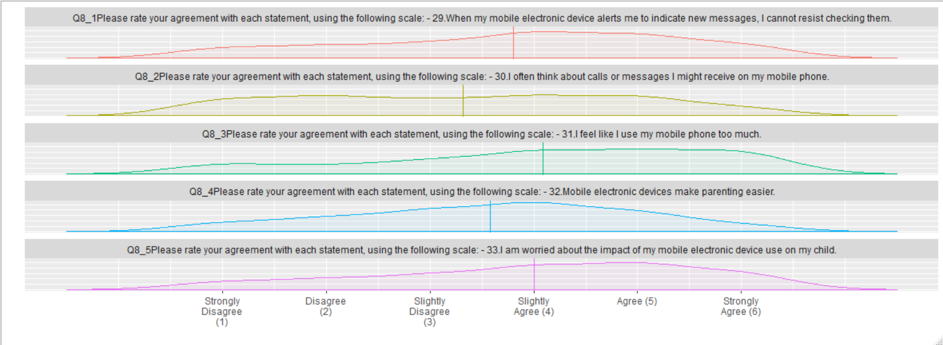

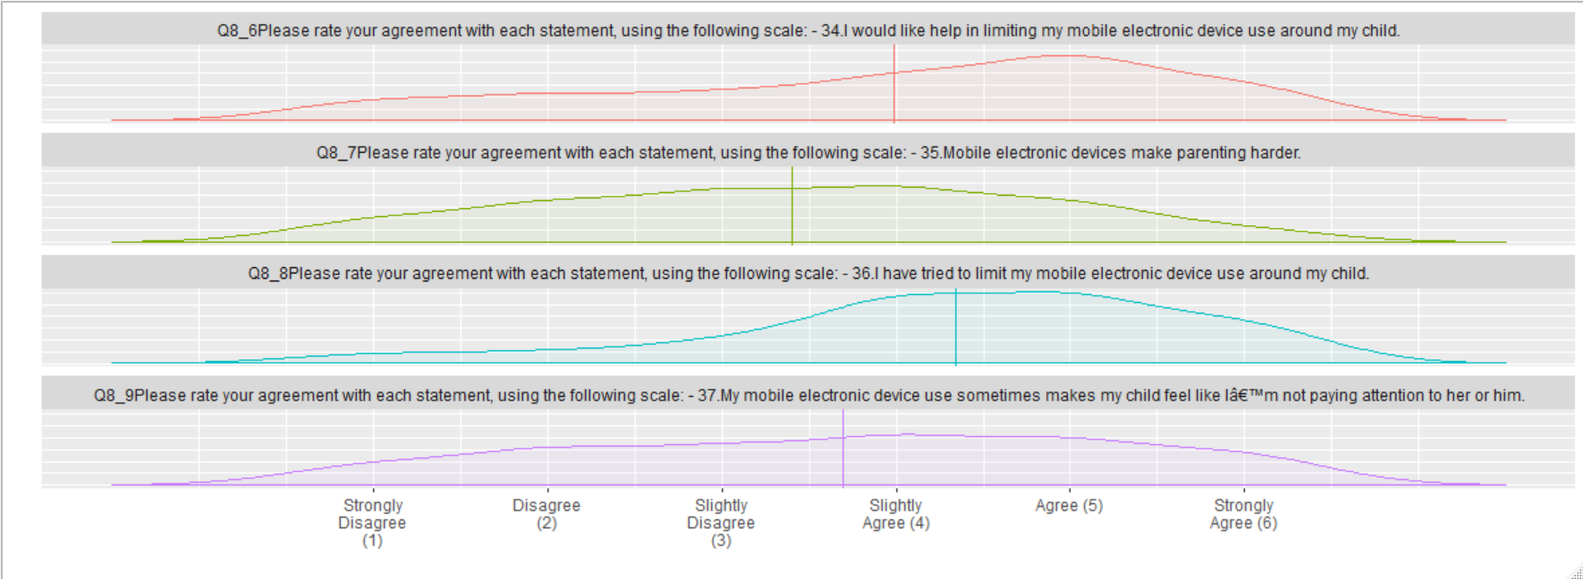

Q9: Please rate your agreement with each statement, using the following scale:

|  |  |  |  |  |
| --- | --- | --- | --- | --- |
| 38. I would like to use electronic devices more effectively, when in my child’s presence. | 1. Strongly Disagree 2. Disagree 3. Slightly Disagree 4. Slightly Agree 5. Agree 6. Strongly Agree | 13 (4.6%) 22 (7.8%) 31 (10.9%) 93 (32.9%) 87 (30.7%) 37 (13.1%) |  | 0 (0%) |
| 39. To help me use electronic devices effectively in my child’s presence - I would attend a class. | 1. Strongly Disagree 2. Disagree 3. Slightly Disagree 4. Slightly Agree 5. Agree 6. Strongly Agree | 55 (19.4%) 50 (17.7%) 47 (16.6%) 63 (22.3%) 46 (16.2%) 22 (7.8%) |  | 0 (0%) |
| 40. To help me use electronic devices effectively in my child’s presence - I would attend a support group with other parents. | 1. Strongly Disagree 2. Disagree 3. Slightly Disagree 4. Slightly Agree 5. Agree 6. Strongly Agree | 48 (17.0%) 59 (20.8%) 48 (17.0%) 68 (24.0%) 44 (15.6%) 16 (5.6%) |  | 0 (0%) |
| 41. To help me use electronic devices effectively in my child’s presence - I would consider help from a coach in my home. | 1. Strongly Disagree 2. Disagree 3. Slightly Disagree 4. Slightly Agree 5. Agree 6. Strongly Agree | 62 (21.9%) 59 (20.8%) 48 (17.0%) 49 (17.3%) 40 (14.1%) 25 (8.8%) |  | 0 (0%) |

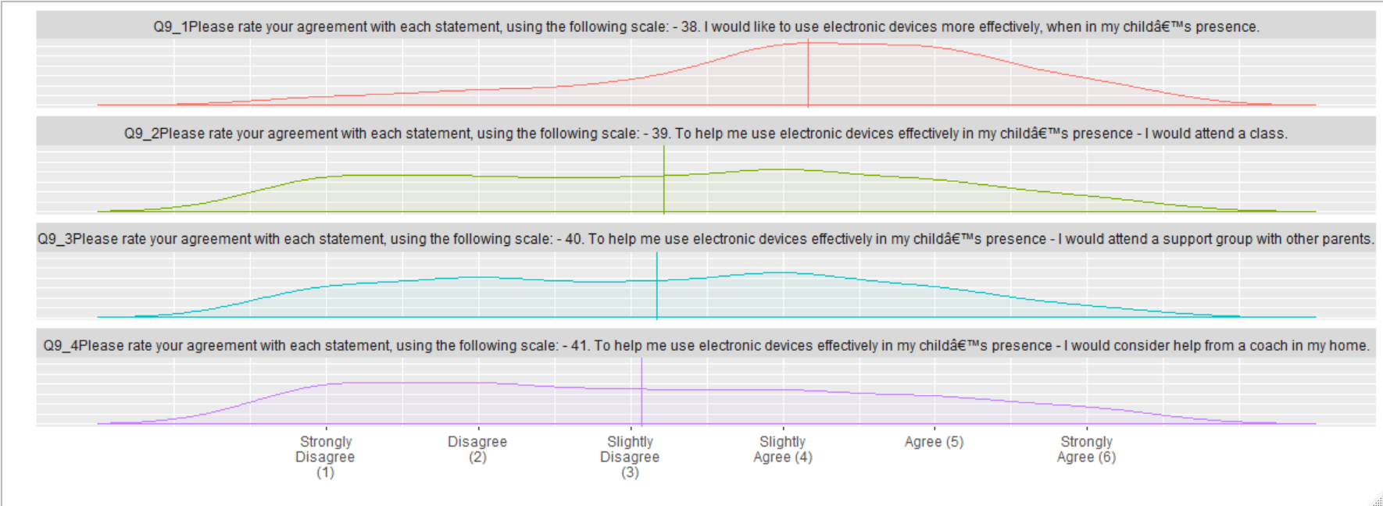

Q10. Please rate your agreement with each statement below, using the following scale:

|  |  |  |  |  |
| --- | --- | --- | --- | --- |
| 42. Using a computer-assisted coach while caring for my child would quickly feel like a normal part of life. | 1. Strongly Disagree 2. Disagree 3. Slightly Disagree 4. Slightly Agree 5. Agree 6. Strongly Agree | 52 (18.4%) 48 (17.0%) 62 (21.9%) 60 (21.2%) 45 (15.9%) 16 (5.6%) |  | 0 (0%) |
| 43. Using a computer-assisted coach while caring for my child would help me be more aware of my device use around my child. | 1. Strongly Disagree 2. Disagree 3. Slightly Disagree 4. Slightly Agree 5. Agree 6. Strongly Agree | 38 (13.4%) 42 (14.8%) 28 (9.9%) 84 (29.7%) 71 (25.1%) 20 (7.1%) |  | 0 (0%) |
| 44. Using a computer-assisted coach while caring for my child would improve my interactions with my child. | 1. Strongly Disagree 2. Disagree 3. Slightly Disagree 4. Slightly Agree 5. Agree 6. Strongly Agree | 43 (15.2%) 38 (13.5%) 53 (18.8%) 75 (26.6%) 55 (19.5%) 18 (6.4%) |  | 1 (0.35%) |
| 45. Using a computer-assisted coach while caring for my child would help me be a better parent. | 1. Strongly Disagree 2. Disagree 3. Slightly Disagree 4. Slightly Agree 5. Agree 6. Strongly Agree | 44 (15.6%) 49 (17.4%) 41 (14.5%) 75 (26.6%) 53 (18.8%) 20 (7.1%) |  | 1 (0.35%) |
| 46. Using a computer-assisted coach while caring for my child would feel like too much technology. | 1. Strongly Disagree 2. Disagree 3. Slightly Disagree 4. Slightly Agree 5. Agree 6. Strongly Agree | 22 (7.8%) 23 (8.2%) 45 (16.0%) 81 (28.7%) 65 (23.1%) 46 (16.3%) |  | 1 (0.35%) |
| 47. Using a computer-assisted coach while caring for my child would raise privacy concerns. | 1. Strongly Disagree 2. Disagree 3. Slightly Disagree 4. Slightly Agree 5. Agree 6. Strongly Agree | 25 (8.8%) 18 (6.4%) 34 (12.0%) 82 (29.0%) 69 (24.4%) 55 (19.4%) |  | 0 (0%) |

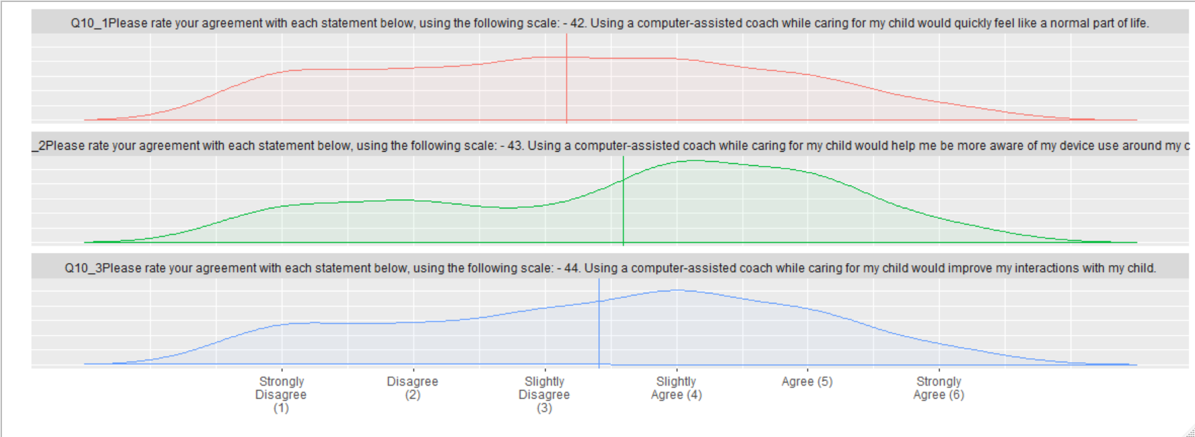

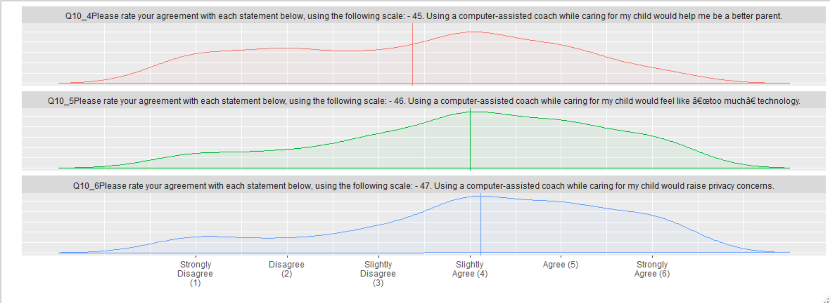

Q29. Please rate your agreement with each statement below, using the following scale:

|  |  |  |  |  |
| --- | --- | --- | --- | --- |
| 48. Using a computer-assisted coach while caring for my child would help me notice more quickly when my device use is interfering with my caregiving. | 1. Strongly Disagree 2. Disagree 3. Slightly Disagree 4. Slightly Agree 5. Agree 6. Strongly Agree | 35 (12.4%) 26 (9.2%) 37 (13.1%) 94 (33.3%) 65 (23.1%) 25 (8.9%) |  | 1 (0.35%) |
| 49. Using a computer-assisted coach while caring for my child would help me keep my attention focused on my child. | 1. Strongly Disagree 2. Disagree 3. Slightly Disagree 4. Slightly Agree 5. Agree 6. Strongly Agree | 37 (13.1%) 40 (14.1%) 37 (13.1%) 83 (29.3%) 67 (23.7%) 19 (6.7%) |  | 0 (0%) |
| 50. Using a computer-assisted coach while caring for my child would help me discuss issues with my child’s doctor. | 1. Strongly Disagree 2. Disagree 3. Slightly Disagree 4. Slightly Agree 5. Agree 6. Strongly Agree | 46 (16.2%) 48 (17.0%) 47 (16.6%) 74 (26.2%) 46 (16.2%) 22 (7.8%) |  | 0 (0%) |
| 51. Using a computer-assisted coach while caring for my child would help me discuss issues with my child’s teacher. | 1. Strongly Disagree 2. Disagree 3. Slightly Disagree 4. Slightly Agree 5. Agree 6. Strongly Agree | 35 (12.4%) 46 (16.2%) 51 (18.0%) 74 (26.2%) 59 (20.8%) 18 (6.4%) |  | 0 (0%) |
| 52. Using a computer-assisted coach while caring for my child would help me discuss issues with my child’s other parent or other caregiver. | 1. Strongly Disagree 2. Disagree 3. Slightly Disagree 4. Slightly Agree 5. Agree 6. Strongly Agree | 40 (14.1%) 44 (15.6%) 53 (18.7%) 69 (24.4%) 55 (19.4%) 22 (7.8%) |  | 0 (0%) |
| 53. Using a computer-assisted coach while caring for my child would be useful to me. | 1. Strongly Disagree 2. Disagree 3. Slightly Disagree 4. Slightly Agree 5. Agree 6. Strongly Agree | 40 (14.1%) 35 (12.4%) 44 (15.6%) 85 (30.0%) 58 (20.5%) 21 (7.4%) |  | 0 (0%) |

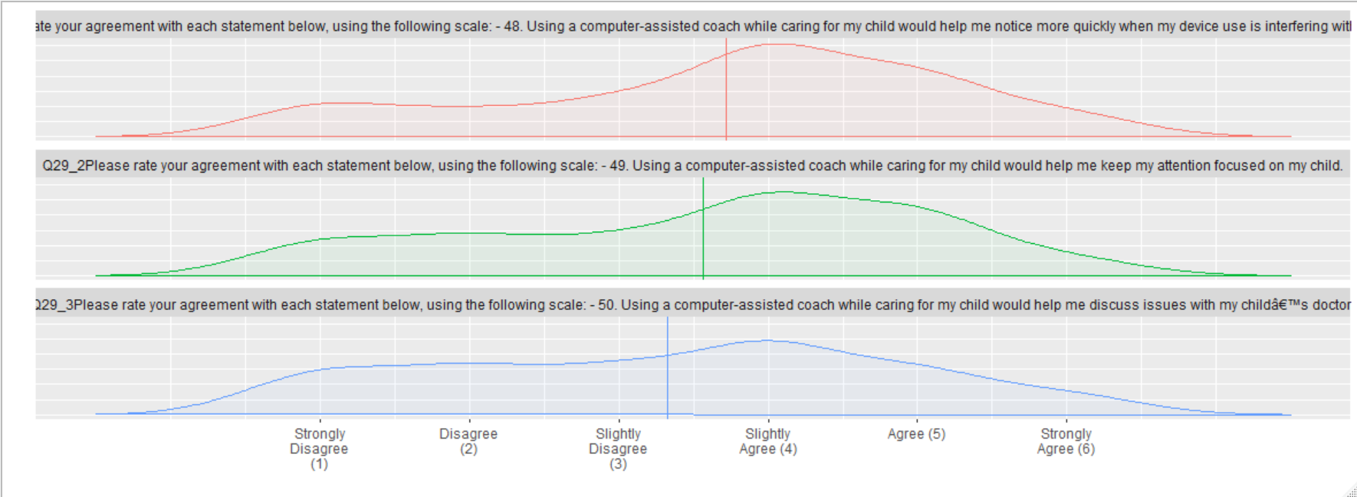

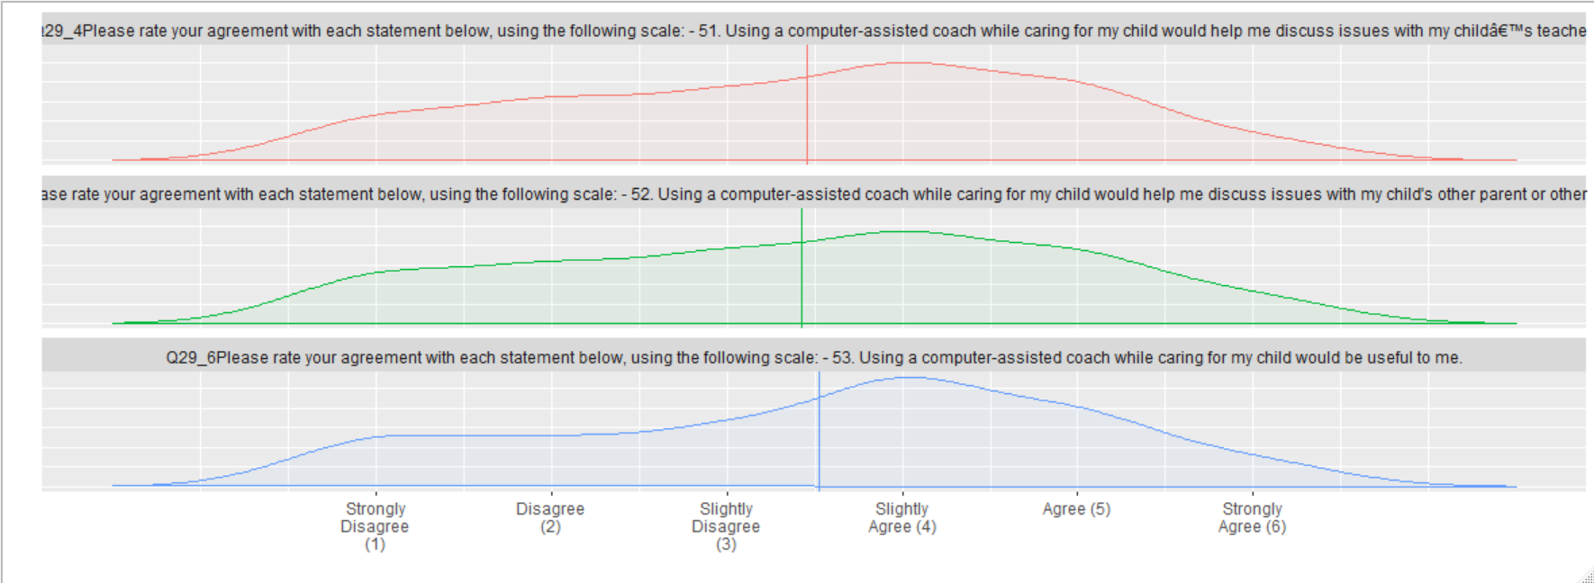

|  |  |  |  |  |
| --- | --- | --- | --- | --- |
| 54. What is your age? | Mean (sd) : 32.9 (8.4) min < med < max: 19 < 32 < 67 IQR (CV) : 12 (0.3) | 39 distinct values |  | 0 (0%) |
| 55. What is your gender? - | 1. Male 2. Female 3. Other | 61 (21.6%) 221 (78.1%) 1 (0.4%) |  | 0 (0%) |
| TEXT55. What is your gender? - Other - Text | 1. 2. -99 3. One of each 2 children | 0 (0.0%) 0 (0.0%) 1 (100.0%) |  | 282 (99.65%) |
| 56. Do you consider yourself to be Hispanic or Latino/a? | 1. Yes 2. No | 73 (25.8%) 210 (74.2%) |  | 0 (0%) |
| 57. What race do you consider yourself to be?  - Selected Choice | 1. White 2. Black 3. Hispanic 4. Asian 5. Pacific Islander 6. American Indian 7. Other | 187 (68.2%) 25 (9.1%) 40 (14.6%) 16 (5.8%) 0 (0.0%) 2 (0.7%) 4 (1.5%) |  | 9 (3.18%) |
| TEXT57. What race do you consider yourself to be? - Other - Text | 1. 2. -99 3. Hispanic 4. Middle eastern | 0 (0.0%) 0 (0.0%) 1 (50.0%) 1 (50.0%) |  | 281 (99.29%) |
| 58. How well do you speak English? Would you say…? | 1. Very Well 2. Well 3. Not Well 4. Not Well At All | 236 (83.4%) 35 (12.4%) 11 (3.9%) 1 (0.4%) |  | 0 (0%) |
| 59. What language do you usually speak at home? - Selected Choice | 1. English 2. Spanish 3. Other | 244 (86.2%) 37 (13.1%) 2 (0.7%) |  | 0 (0%) |
| TEXT59. What language do you usually speak at home?  - Other - Text | 1. 2. -99 3. Both 4. Both English and Spanish | 0 (0.0%) 0 (0.0%) 0 (0.0%) 1 (100.0%) |  | 282 (99.65%) |
| 60. How long have you lived in the United States? | 1. I was born in the U.S. 2. Less than a year 3. 1-2 years 4. 2-5 years 5. 5+ years | 187 (66.1%) 1 (0.4%) 5 (1.8%) 18 (6.4%) 72 (25.4%) |  | 0 (0%) |
| 61. How would you describe your marital status? - Selected Choice | 1. Single, Never married 2. Living with a Partner 3. Married 4. Separated 5. Divorced 6. Widowed 7. Other | 41 (14.5%) 49 (17.3%) 172 (60.8%) 7 (2.5%) 9 (3.2%) 5 (1.8%) 0 (0.0%) |  | 0 (0%) |
| TEXT61. How would you describe your marital status? - Other - Text | 1. 2. -99 | All NA’s |  | 283 (100%) |
| 62. Including yourself, how many people live in your home? | Mean (sd) : 4 (1.4) min < med < max: 1 < 4 < 9 IQR (CV) : 2 (0.4) | 1 : 4 (1.4%) 2 : 24 (8.5%) 3 : 88 (31.1%) 4 : 84 (29.7%) 5 : 46 (16.2%) 6 : 24 (8.5%) 7 : 4 (1.4%) 8 : 8 (2.8%) 9 : 1 (0.4%) |  | 0 (0%) |
| 63. How many children do you have? | Mean (sd) : 2 (1.1) min < med < max: 1 < 2 < 7 IQR (CV) : 2 (0.5) | 1 : 109 (38.5%) 2 : 95 (33.6%) 3 : 48 (17.0%) 4 : 23 (8.1%) 5 : 6 (2.1%) 6 : 1 (0.4%) 7 : 1 (0.4%) |  | 0 (0%) |
| 64. What is the age of your YOUNGEST CHILD? | Mean (sd) : 3.1 (1.6) min < med < max: 1 < 4 < 5 IQR (CV) : 3 (0.5) | 1 : 70 (24.7%) 2 : 40 (14.1%) 3 : 26 (9.2%) 4 : 74 (26.2%) 5 : 73 (25.8%) |  | 0 (0%) |
| Q24  - 65. What is the highest level of school you have completed or the highest degree you have received? | 1. Less than HS degree 2. HS degree or equivalent (e.g., GED) 3. Some college but no degree 4. Associates Degree 5. Bachelor’s Degree 6. Graduate Degree | 13 (4.6%) 69 (24.4%)  64 (22.6%) 35 (12.4%) 71 (25.1%) 31 (10.9%) |  | 0 (0%) |
| 66. Right now, do you work? | 1. Yes 2. No | 173 (61.1%) 110 (38.9%) |  | 0 (0%) |
| 67. Are you working part time or full time? - Selected Choice | 1. Part-time 2. Full-time 3. other | 31 (17.9%) 141 (81.5%) 1 (0.6%) |  | 110 (38.87%) |
| TEXT67. Are you working part time or full time?  - Other - Text | 1. 2. -99 | 110 (100.0%) 0 (0.0%) |  | 173 (61.13%) |
| 68. Please mark the group that is closest to your total household income in the past 12 months. | 1. <$25k 2. $25k - <$50k 3. $50k - <$75k 4. $75k - <$100k 5. $100k - <$125k 6. $125k - <$150k 7. 150k - <$175k 8. $175k - <$200k 9. >=$200k | 56 (19.8%) 69 (24.4%) 67 (23.7%) 48 (17.0%) 22 (7.8%) 11 (3.9%) 7 (2.5%) 1 (0.4%) 2 (0.7%) |  | 0 (0%) |

Please rate your agreement with each statement, using the following scale:  
  
Parent Technoference Scale (for Questions 29-31)

|  |  |  |  |  |  |  |
| --- | --- | --- | --- | --- | --- | --- |
|  | **Total** | | **Education** **level** | | **Sex** | |
|  |  |  | HS or Less  (n = 82) | College or More  (n = 200) | Male  (n = 61) | Female  (n = 221) |
| 29. When my mobile  electronic device alerts me to indicate new messages, I cannot resist  checking them | **Mean** | 3.79 | 3.40 | 3.96 | 4.13 | 3.70 |
|  | Std. dev. | 1.53 | 1.58 | 1.49 | 1.53 | 1.52 |
| 30. I often think about  calls or messages I might  receive on my mobile  phone. | **Mean** | 3.32 | 3.09 | 3.41 | 3.56 | 3.25 |
|  | Std. dev. | 1.60 | 1.61 | 1.59 | 1.66 | 1.58 |
| 31. I feel like I use my  mobile phone too much. | **Mean** | 4.08 | 3.72 | 4.23 | 4.16 | 4.06 |
|  | Std. dev. | 1.59 | 1.72 | 1.52 | 1.58 | 1.60 |
|  | **Cronbach’s α** | .80 | .76 | .82 | .87 | .78 |

Subgrouped by Education and Language   
*(n = 243 for “English at Home”; n = 39 for “Non-English at Home”)*

|  |  |  |  |  |
| --- | --- | --- | --- | --- |
| 29. When my mobile electronic device alerts me to indicate new messages, I cannot resist checking them. | *High Schopl or Less*  1. Strongly Disagree 2. Disagree 3. Slightly Disagree 4. Slightly Agree 5. Agree 6. Strongly Agree  *College or More* 1. Strongly Disagree 2. Disagree 3. Slightly Disagree 4. Slightly Agree 5. Agree 6. Strongly Agree  *English at Home* 1. Strongly Disagree 2. Disagree 3. Slightly Disagree 4. Slightly Agree 5. Agree 6. Strongly Agree  *Non-English at Home*  1. Strongly Disagree 2. Disagree 3. Slightly Disagree 4. Slightly Agree 5. Agree 6. Strongly Agree | 13 (15.8%) 12 (14.6%) 17 (20.7%) 18 (21.9%) 13 (15.8%) 9 (11.0%)  17 ( 8.5%) 23 (11.4%) 24 (11.9%) 54 (26.9%) 52 (25.9%) 31 (15.4%)   24 ( 9.9%) 31 (12.8%) 32 (13.2%) 67 (27.6%) 57 (23.5%) 32 (13.2%)  6 (15.4%) 4 (10.3%) 9 (23.1%) 5 (12.8%) 8 (20.5%) 7 (17.9%) |  | 0 (0%)  0 (0%)  0 (0%)  0 (0%) |

|  |  |  |  |  |
| --- | --- | --- | --- | --- |
| 30. I often think about calls or messages I might receive on my mobile phone. | *High School or Less*  1. Strongly Disagree 2. Disagree 3. Slightly Disagree 4. Slightly Agree 5. Agree 6. Strongly Agree  *College or More* 1. Strongly Disagree 2. Disagree 3. Slightly Disagree 4. Slightly Agree 5. Agree 6. Strongly Agree  *English at Home*  1. Strongly Disagree 2. Disagree 3. Slightly Disagree 4. Slightly Agree 5. Agree 6. Strongly Agree  *Non-English at Home*  1. Strongly Disagree 2. Disagree 3. Slightly Disagree 4. Slightly Agree 5. Agree 6. Strongly Agree | 18 (21.9%) 16 (19.5%)  14 (17.1%) 16 (19.5%) 11 (13.4%) 7 ( 8.5%)  30 (14.9%) 39 (19.4%) 31 (15.4%) 39 (19.4%) 44 (21.9%) 18 ( 9.0%)  47 (19.3%) 46 (18.9%) 38 (15.6%) 45 (18.5%) 48 (19.8%) 19 ( 7.8%)  1 ( 2.6%) 9 (23.1%) 6 (15.4%) 10 (25.6%) 7 (17.9%) 6 (15.4%) |  | 0 (0%)  0 (0%)  0 (0%)  0 (0%) |

|  |  |  |  |  |
| --- | --- | --- | --- | --- |
| 31. I feel like I use my mobile phone too much. | *High School or Less*  1. Strongly Disagree 2. Disagree 3. Slightly Disagree 4. Slightly Agree 5. Agree 6. Strongly Agree  *College or More* 1. Strongly Disagree 2. Disagree 3. Slightly Disagree 4. Slightly Agree 5. Agree 6. Strongly Agree  *English at Home*  1. Strongly Disagree 2. Disagree 3. Slightly Disagree 4. Slightly Agree 5. Agree 6. Strongly Agree  *Non-English at Home*  1. Strongly Disagree 2. Disagree 3. Slightly Disagree 4. Slightly Agree 5. Agree 6. Strongly Agree | 12 (14.6%) 9 (11.0%) 17 (20.7%) 15 (18.3%) 10 (12.2%) 19 (23.2%)  17 ( 8.5%) 14 ( 7.0%) 21 (10.4%) 48 (23.9%) 55 (27.4%) 46 (22.9%)   28 (11.5%) 22 ( 9.0%) 28 (11.5%) 53 (21.8%) 54 (22.2%) 58 (23.9%)   1 ( 2.6%) 1 ( 2.6%) 10 (25.6%) 10 (25.6%) 10 (25.6%) 7 (17.9%) |  | 0 (0%)  0 (0%)  0 (0%)  0 (0%) |

|  |  |  |  |  |
| --- | --- | --- | --- | --- |
| 33. I am worried about the impact of my mobile electronic device use on my child. | *High School or Less*  1. Strongly Disagree 2. Disagree 3. Slightly Disagree 4. Slightly Agree 5. Agree 6. Strongly Agree  *College or More*  1. Strongly Disagree 2. Disagree 3. Slightly Disagree 4. Slightly Agree 5. Agree 6. Strongly Agree  *English at Home*  1. Strongly Disagree 2. Disagree 3. Slightly Disagree 4. Slightly Agree 5. Agree 6. Strongly Agree  *Non-English at Home*  1. Strongly Disagree 2. Disagree 3. Slightly Disagree 4. Slightly Agree 5. Agree 6. Strongly Agree | 12 (14.8%) 5 (6.2%) 17 (21.0%) 12 (14.8%) 21 (25.9%) 14 (17.3%)  11 (5.5%) 25 (12.5%) 24 (12.0%) 53 (26.5%) 52 (26.0%) 35 (17.5%)  22 ( 9.1%) 27 (11.2%) 34 (14.1%) 54 (22.3%) 67 (27.7%) 38 (15.7%)  1 ( 2.6%) 2 ( 5.3%) 7 (18.4%) 11 (28.9%) 6 (15.8%) 11 (28.9%) |  | 0 (0%)  0 (0%)  1 (0.41%)  1 (2.56%) |

|  |  |  |  |  |
| --- | --- | --- | --- | --- |
| 34. I would like help in limiting my mobile electronic device use around my child. | *High School or Less*  1. Strongly Disagree 2. Disagree 3. Slightly Disagree 4. Slightly Agree 5. Agree 6. Strongly Agree  *College or More*  1. Strongly Disagree 2. Disagree 3. Slightly Disagree 4. Slightly Agree 5. Agree 6. Strongly Agree  *English at Home*  1. Strongly Disagree 2. Disagree 3. Slightly Disagree 4. Slightly Agree 5. Agree 6. Strongly Agree  *Non-English at Home*  1. Strongly Disagree 2. Disagree 3. Slightly Disagree 4. Slightly Agree 5. Agree 6. Strongly Agree | 11 (13.6%) 10 (12.3%) 13 (16.1%) 14 (17.3%) 20 (24.7%) 13 (16.1%)  16 (8.0%) 23 (11.4%) 22 (10.9%) 42 (20.9%) 64 (31.8%) 34 (16.9%)   27 (11.1%) 28 (11.5%) 28 (11.5%) 46 (18.9%) 77 (31.7%) 37 (15.2%)  0 ( 0.0%) 4 (10.5%) 7 (18.4%) 10 (26.3%) 7 (18.4%) 10 (26.3%) |  | 1 (1.22%)  0 (0%)        0 (0%)        1 (2.56%) |

Some electronic devices are currently being designed to HELP you have a better connection with your child – by coaching you or giving you meaningful, real-time feedback.

Imagine such a “computer-assisted coach,” which you could use in your home to get feedback on your use of electronic devices while caring for your child. The computer-assisted coach would automatically analyze computer vision and other data to provide the feedback. Whenever you want, you could turn this computer-assisted coach on or off.

Q10. Please rate your agreement with each statement below, using the following scale:

|  |  |  |  |  |
| --- | --- | --- | --- | --- |
| 44. Using a computer-assisted coach while caring for my child would improve my interactions with my child. | *High School or Less*  1. Strongly Disagree 2. Disagree 3. Slightly Disagree 4. Slightly Agree 5. Agree 6. Strongly Agree  *College or More*  1. Strongly Disagree 2. Disagree 3. Slightly Disagree 4. Slightly Agree 5. Agree 6. Strongly Agree  *English at Home*  1. Strongly Disagree 2. Disagree 3. Slightly Disagree 4. Slightly Agree 5. Agree 6. Strongly Agree  *Non-English at Home*  1. Strongly Disagree 2. Disagree 3. Slightly Disagree 4. Slightly Agree 5. Agree 6. Strongly Agree | 19 (23.2%) 14 (17.1%) 13 (15.8%) 17 (20.7%) 16 (19.5%) 3 (3.7%)    24 (12.0%) 24 (12.0%) 40 (20.0%) 58 (29.0%) 39 (19.5%) 15 (7.5%)   38 (15.7%) 34 (14.1%) 46 (19.0%) 62 (25.6%) 47 (19.4%) 15 ( 6.2%)   5 (12.8%) 4 (10.3%) 7 (17.9%) 13 (33.3%) 7 (17.9%) 3 ( 7.7%) |  | 0 (0%)  1 (0.5%)  1 (0.41%)    0 (0%) |
| 45. Using a computer-assisted coach while caring for my child would help me be a better parent. | *High School or Less*  1. Strongly Disagree 2. Disagree 3. Slightly Disagree 4. Slightly Agree 5. Agree 6. Strongly Agree  *College or More*  1. Strongly Disagree 2. Disagree 3. Slightly Disagree 4. Slightly Agree 5. Agree 6. Strongly Agree  *English at Home*  1. Strongly Disagree 2. Disagree 3. Slightly Disagree 4. Slightly Agree 5. Agree 6. Strongly Agree  *Non-English at Home*  1. Strongly Disagree 2. Disagree 3. Slightly Disagree 4. Slightly Agree 5. Agree 6. Strongly Agree | 15 (18.3%) 20 (24.4%) 14 (17.1%) 17 (20.7%) 10 (12.2%) 6 (7.3%)  29 (14.5%) 29 (14.5%) 27 (13.5%) 58 (29.0%) 43 (21.5%) 14 (7.0%)   40 (16.5%) 40 (16.5%) 34 (14.1%) 69 (28.5%) 44 (18.2%) 15 ( 6.2%)  4 (10.3%) 9 (23.1%) 6 (15.4%) 6 (15.4%) 9 (23.1%) 5 (12.8%) |  | 0 (0%)  0 (0%)  1 (0.41%)  0 (0%) |

|  |  |  |  |  |
| --- | --- | --- | --- | --- |
| 46. Using a computer-assisted coach while caring for my child would feel like too much technology. | *High School or Less*  1. Strongly Disagree 2. Disagree 3. Slightly Disagree 4. Slightly Agree 5. Agree 6. Strongly Agree  *College or More*  1. Strongly Disagree 2. Disagree 3. Slightly Disagree 4. Slightly Agree 5. Agree 6. Strongly Agree  *English at Home*  1. Strongly Disagree 2. Disagree 3. Slightly Disagree 4. Slightly Agree 5. Agree 6. Strongly Agree  *Non-English at Home*  1. Strongly Disagree 2. Disagree 3. Slightly Disagree 4. Slightly Agree 5. Agree 6. Strongly Agree | 9 (11.0%) 5 (6.1%) 17 (20.7%) 15 (18.3%) 21 (25.6%) 15 (18.3%)  13 (6.5%) 18 (9.0%) 28 (14.0%) 66 (33.0%) 44 (22.0%) 31 (15.5%)   18 ( 7.4%) 20 ( 8.3%) 36 (14.9%) 72 (29.8%) 54 (22.3%) 42 (17.4%)  3 ( 7.7%) 3 ( 7.7%) 9 (23.1%) 9 (23.1%) 11 (28.2%) 4 (10.3%) |  | 0 (0%)  1 (0.5%)       1 (0.41%)         0 (0%) |

|  |  |  |  |  |
| --- | --- | --- | --- | --- |
| 47. Using a computer-assisted coach while caring for my child would raise privacy concerns. | *High School or Less*  1. Strongly Disagree 2. Disagree 3. Slightly Disagree 4. Slightly Agree 5. Agree 6. Strongly Agree  *College or More*  1. Strongly Disagree 2. Disagree 3. Slightly Disagree 4. Slightly Agree 5. Agree 6. Strongly Agree  *English at Home*  1. Strongly Disagree 2. Disagree 3. Slightly Disagree 4. Slightly Agree 5. Agree 6. Strongly Agree  *Non-English at Home*  1. Strongly Disagree 2. Disagree 3. Slightly Disagree 4. Slightly Agree 5. Agree 6. Strongly Agree | 8 (9.8%) 8 (9.8%) 14 (17.1%) 21 (25.6%) 20 (24.4%) 11 (13.4%)  17 (8.5%) 10 (5.0%) 20 (10.0%) 61 (30.3%) 49 (24.4%) 44 (21.9%)   21 ( 8.6%) 16 ( 6.6%) 26 (10.7%) 67 (27.6%) 60 (24.7%) 53 (21.8%)   3 ( 7.7%) 2 ( 5.1%) 8 (20.5%) 15 (38.5%) 9 (23.1%) 2 ( 5.1%) |  | 0 (0%)  0 (0%)    0 (0%)  0 (0%) |

|  |  |  |  |  |
| --- | --- | --- | --- | --- |
| 53. Using a computer-assisted coach while caring for my child would be useful to me. | *High School or Less*  1. Strongly Disagree 2. Disagree 3. Slightly Disagree 4. Slightly Agree 5. Agree 6. Strongly Agree  *College or More*  1. Strongly Disagree 2. Disagree 3. Slightly Disagree 4. Slightly Agree 5. Agree 6. Strongly Agree  *English at Home*  1. Strongly Disagree 2. Disagree 3. Slightly Disagree 4. Slightly Agree 5. Agree 6. Strongly Agree  *Non-English at Home*  1. Strongly Disagree 2. Disagree 3. Slightly Disagree 4. Slightly Agree 5. Agree 6. Strongly Agree | 16 (19.5%) 11 (13.4%) 12 (14.6%) 21 (25.6%) 14 (17.1%) 8 (9.8%)  24 (11.9%) 24 (11.9%) 32 (15.9%) 64 (31.8%) 44 (21.9%) 13 (6.5%)   37 (15.2%) 28 (11.5%) 40 (16.5%) 73 (30.0%) 47 (19.3%) 18 ( 7.4%)   3 ( 7.7%) 7 (17.9%) 4 (10.3%) 11 (28.2%) 11 (28.2%) 3 ( 7.7%) |  | 0 (0%)  0 (0%)    0 (0%)  0 (0%) |